Approved by Leonid Vasilyev (WKF 7 Dan)
Latvian Karate Federation President

6th Open Salaspils Karate Cup
Organizator: „Salaspils Karate Club” in cooperation with”Latvian Karate Federation”.
Date: 16th May, 2015, 10 ⁰⁰
Registration and weighting from 8³⁰ till 9³⁰
Personal document or passport is obligatory for all sportsmen.
From 9 ³⁰ till 10 ⁰⁰ team representatives and coaches briefing.
The beginning of competition at 10 ⁰⁰.
Place: LATVIA, SALASPILS, Smilsu street 1, Salaspils Sport Hall (17 km from Riga, the capital of Latvia).
Rules: WKF rules with changes.
Till 11 years fight time is 1 minute.
12-13 years – 1min.30sec.
Starting with 14 years - WKF rules.
Any kata may be completed in kata categories.
In categories till 9 years old participants may compete with 1 kata,
10-11 years - two kata, 12-13 years - three kata, 14+ years old - WKF Rules.

Chief referee: Igors Ponomarenko +371 29 462 653
Chief secretary: Aleksandrs Kudrajvcevs +371 29 451 616
Foreign referees are welcomed.
Protest 100 EUR.
Entry fee: Medical insurance policy for all sportsmen is obligatry.
- participation in 1 category – 15 EUR
- 2 categories – 30 EUR
- 3 categories – 45 EUR
Team kata and kumite 30 EUR for team.

Rewards: Salaspils Karate Club rewards the first place winners with medals,
cups and diplomas, 2nd and 3 ^{rd} place winners with medals and diplomas and
prizes from sponsors.
Team kata and kumite 1st, 2nd and 3rd place winners with cups, medals and diplomas.
Three best teams are rewarded with cups.
Registration: by e-mail: karatila@inbox.lv (registration form by e-mail).
Deadline for entries is 12.05.2015
Contact information: +371 29788753 Romans Sledzevskis – the organizator of the competition (Latvian, Russian).
+371 28443352 Karina Sledzevska (English).
Categories KATA:
Olympic system with two 3rd places. In categories till 13 years old sportists complete kata at the same time, the finals and fights for third place are separately. Starting with 14 years old - WKF rules.
Boys
U8 Precise Kju
U10 - 9 kyu; - 7 kyu; Open.
U12 - 9 kju; - 7 kju; Open.
U14 - 9 kyu; Open.
U16 Open
U18 Open
+18 Open (money prize 1st place 100 Euro).

Girls
Girls categories are considered after registration form is received.
-9 y. Precise Kju
10 - 15 y. Precise Kju
+ 16y. Open
Kategories SUMO:
Round - robin system (TATAMI „3 X 3”, 2 judges, till 2 YUKO).
Sumo categories are considered after registration form is received (boys and girls separately).

4 y. Precise weight
5 y. Precise weight
6 y. Precise weight
7 y. Precise weight
8 y. Precise weight

Categories KUMITE:
Olympic system with one two 3rd places. (till 13 years old, till 6 points) starting with 14 years old - WKF rules.
Boys Weight
U10 - 35 kg; + 35 kg.
U12 - 35kg; - 40kg; + 40 kg.
U14 - 40kg; - 50kg; + 50 kg; Open.
U16 -52kg; - 57kg; - 63kg; + 63kg; Open.
U18 - 68 kg; - 76kg; + 76kg; Open.
U21 Open
+18y. Open (money prize 1st place 100 Euro).
Girls
Girls categories are considered after registration form is received.
U10 Precise weight
U12 Precise weight
U14 Precise weight
+14 y. Precise weight and yers
Team KUMITE:
One sportist in each age.
U10 + U12 + U14
U15 + U18 + U21

Team KATA : (boys and girls are together)

-9 y. (compete with 1 different katas ).
10-12 y. (compete with 2 different katas).
+13 y. (compete with 3 different katas).

If sportist is not registrated according his/her category, he/she is disqualified and is not allowed to take part in the competition. In such case money is not paid back!
Please, note precise weight and kju in registration form.
Organizator reserves the right to changed categories.

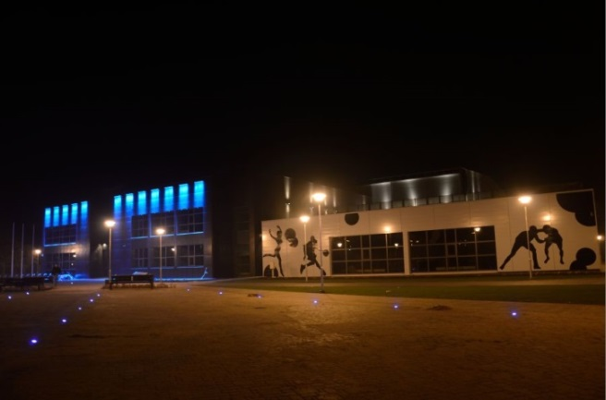

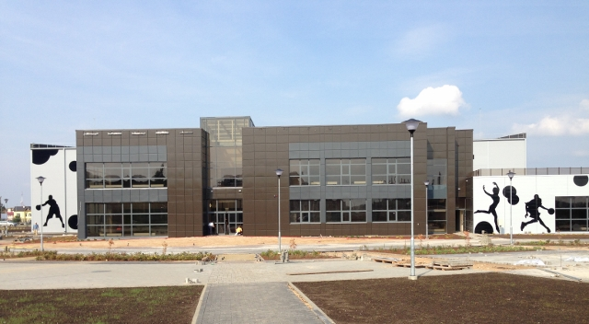

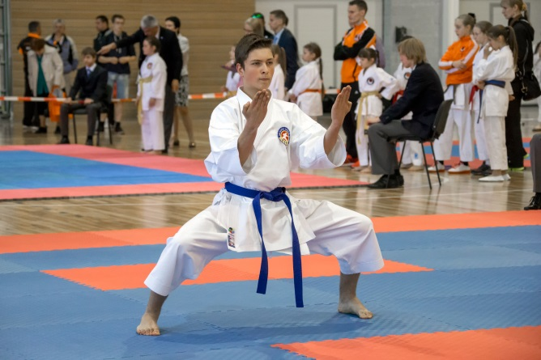

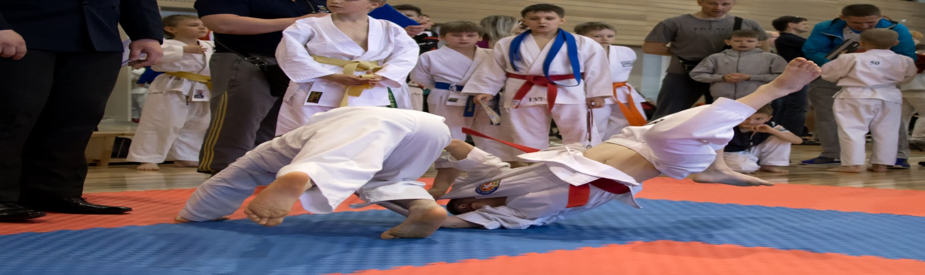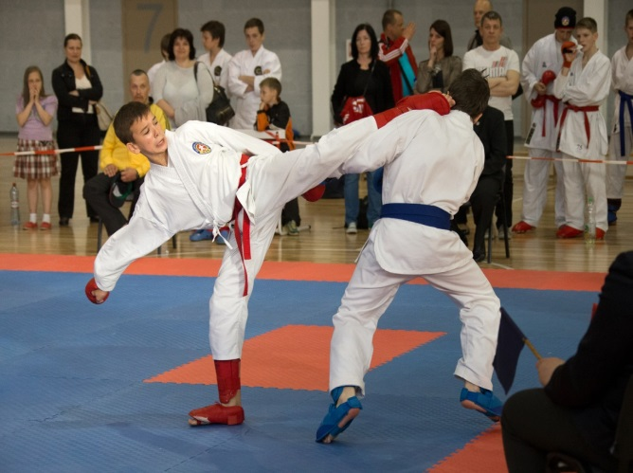

Best Regards,
Romans Sledzevskis
Chairman of Organizing Committee

+371 29788753
E-mail: karatila@inbox.lv
Web: www.rkk.lv

In cooperation with:

